Day8

=======

https://github.com/Jay-Wani/dockercompose.git

docker-compose up –d

docker-compose down

docker-compose.yml file contents

****************************************

wordpress:

image: wordpress

links:

- mysql:mysql

ports:

- 8080:80

mysql:

image: mysql

environment:

- MYSQL_ROOT_PASSWORD=password

****************************************

Commands to work:

Take 3 nodes , 1 manager and 2 workers

docker images

docker ps

git

git clone <https://github.com/Jay-Wani/dockercompose.git>

ls

cd dockercompose/

ls

docker-compose.yml

cat docker-compose.yml

docker-compose up -d

Note: using docker-compose u cannot use orchestration

Docker-compose is for using mul containers in same machine

Both the containers are up and running

docker ps

click on 8080 port at top -> navigates to wordpress website

wordpress is up and running

docker-compose down

docker ps -a

docker images ( yes it is still present)

docker-compose up (without -d will get all the logs in the screen)

-----over------------------

========================================================

https://github.com/Jay-Wani/dockercompose.git

docker-compose.yml file contents

****************************************

wordpress:

image: wordpress

links:

- mysql:mysql

ports:

- 8080:80

mysql:

image: mysql

environment:

- MYSQL_ROOT_PASSWORD=password

Day 9

Docker stack

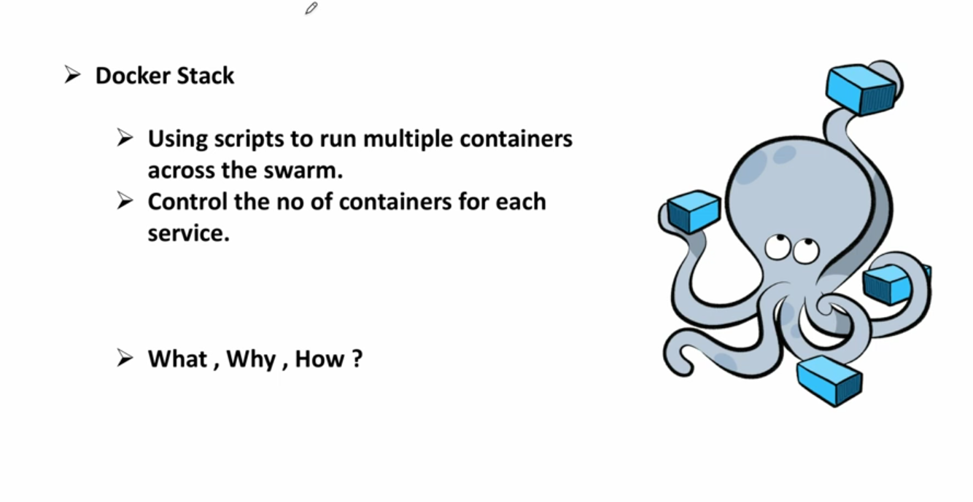

Stack is collection of diff services

Take 1 master and 4 worker nodes

docker ps

docker node ls

git clone <https://github.com/Jay-Wani/dockerstack.git>

ls

dockerstack

cd dockerstack/

cat docker-stack.yml

docker stack deploy --compose-file docker-stack.yml wordp

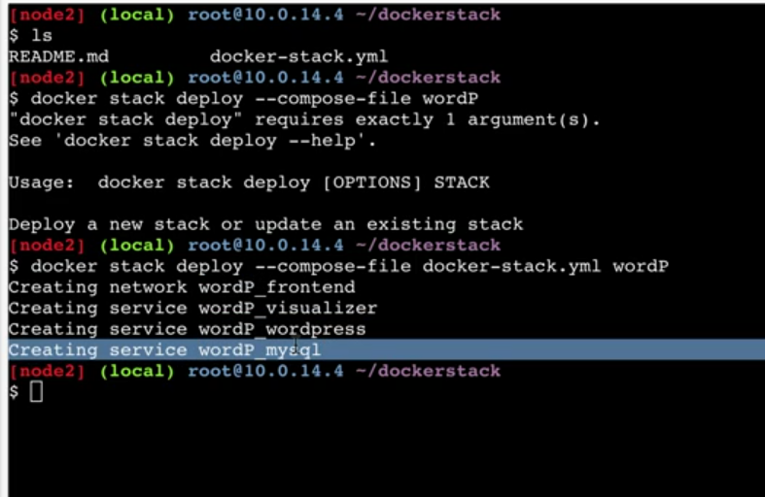

Two ports have been opened up 8080 and 9000

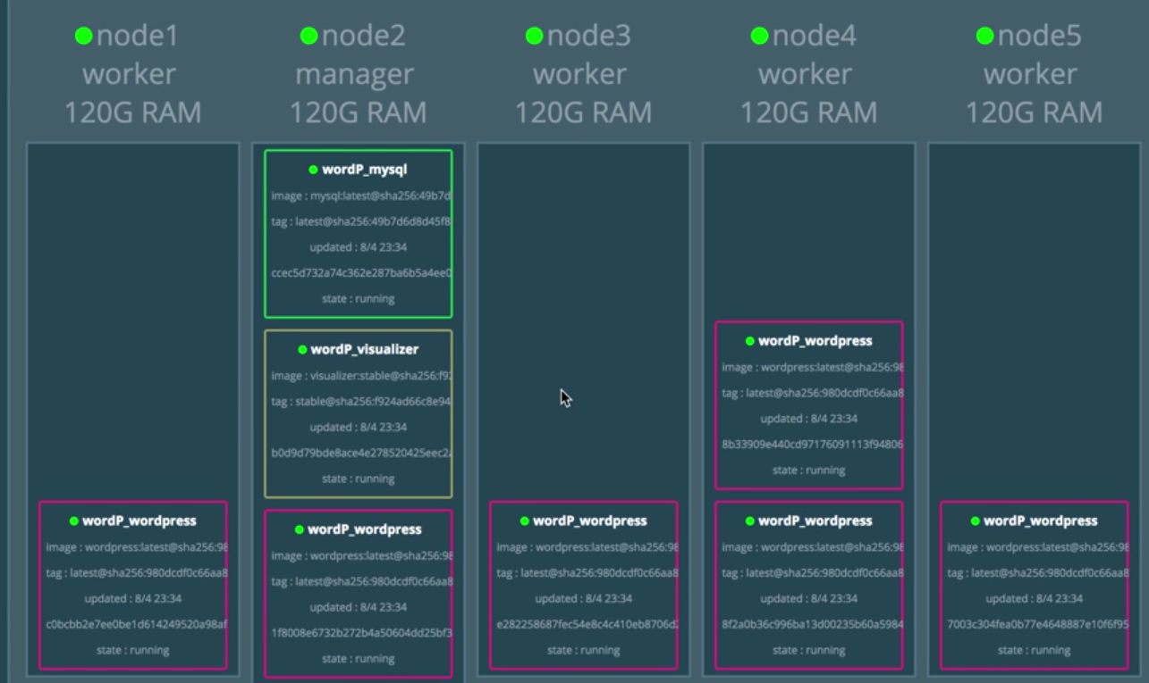

Stack s smart that it spread the containers across node and followed conatraints

Docker ps

Docker stack is combination of docker services

You’ve diff services that are grouped together to create stack and spun up in one go using docker stack command

docker service ls

docker service ps wordP_wordpress

docker service update –replicas=12 wordP_wordpress

Day 10

Docker for AWS / Azure

Orchestration at infrastructure level i.2 AWS / Azure

Orchestration at container level

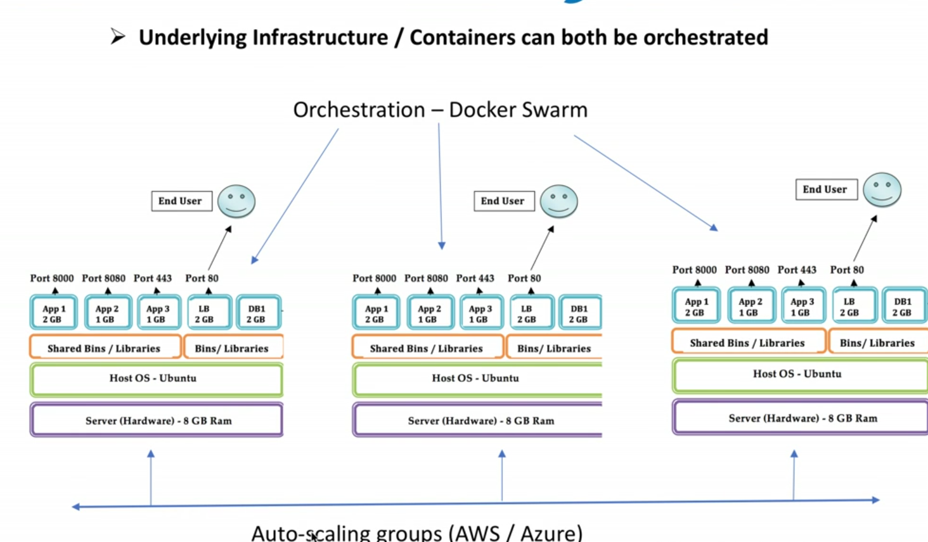

Auto scaling

Create 2 more servers when more number of users

And delete few when no load on website

Unbreakable infra we are building

We need to architect well

Saving and self healing

Google: docker for azure , login and it will show template custom deployment

Search aws market place